**Soldering station**

|  |  |
| --- | --- |
| Author | Jonas Vanhulst |

Content

1 Introduction 3

2 Material and methods 4

2.1 Material 4

2.1.1 Comparing of components 4

2.2 Used Software 5

2.2.2 Bill of materials 6

2.3 Methods 7

2.3.1 Route representation 7

3 Results 8

3.1 Functionality Electrical schematic’s 8

3.1.1 Power source 8

3.1.2 Pulse width modulation 9

3.1.3 Microprocessor 10

3.1.4 Display 11

3.1.5 Thermocouple 12

3.2 PCB Design 13

3.2.1 Display 13

3.2.2 Processor 13

3.2.3 3D view 14

3.3 Case Design 15

3.3.1 Case 15

4 Discussion 16

4.1 Debugging and fixing 16

4.1.1 Processor print 16

4.1.2 Display print 16

4.1.3 Case design 16

4.2 Reflection 17

5 Reference list 17

Image Content

Figure 1 Components 6

Figure 2 Route representation 7

Figure 3 Schematic power source 8

Figure 4 Schematic_Design_Pulse_width_modulation 9

Figure 5 Schematic Design Microprocessor 10

Figure 6 Schematic_Design_Display 11

Figure 7 Schematic_Design_Thermocouple 12

Figure 8 PCB_Design_Display 13

Figure 9 PCB_Design_Processor 13

Figure 10 3D_Design_Display 14

Figure 11 3D_Design_Processor 14

Figure 12 Case_Design 15

# Introduction

This application note describes the building of a soldering station from scratch. Thanks to the Elector mag-azine, it was easier to start. The main goal was to let ELECTRONICS-ICT students learn how to work and use some products inclusive software. The main characteristics of a soldering station are that this device will heat up very fast. This effect was created by the chosen soldering iron and its toroidal transformer. By using the Weller iron, it would be supplied by a 60VA transformer. More about this will follow in this note. After assembling this soldering station, it will be used to solder electronic components on a PCB (Printed circuit board).

Firstly, the used choices about through hole and SMD-components will be explained, further there is a complete overview about the project. At the end of this application note, there will be a discussion about the results and the references used.

# Material and methods

## Material

### Comparing of components

At the beginning of this project, the choice between Trough hole and SMD components becomes crucial in the PCB design.

Before finalizing the order and making a definitive decision, it was wise to assess the availability of components at home. After checking all the components, the decision was made to use only SMD resistors and capacitors. This decision was made by the fact that a lot of spare parts were available at home in Through hole what is ideal for prototyping.

When ordering components, it is advisable to consider the expected delivery date. This is currently an important factor. Consequently, orders were placed with reputable manufacturers such as Farnell, Amazon, TME, and RS-components, known for there swift delivery and reasonable prices. It is worth noting that ordering from within Europe may result in higher taxes and delivery costs as compared to ordering from China.

## Used Software

#### Altium Designer

All the design of the PCB was done with Altium Designer. The school gave us this strong program used by professionals in the work field. Also, there were a lot of problems finding the right parts and footprints. Some parts are just too old to find in the current database. By requesting those components from Ultra Librarian, the old components could be placed.

#### Fushion 360

Fusion 360 is a cloud-based 3D modelling program. In this software you are allowed to modelling CAD,CAM,CAE and also to do PCB design. By importing the 3D-PCB designed from Altium Designer, I could fit the PCB into the case. This is very useful for avoiding problems while testing the final result.

#### Prusaslicer

The Prusaslicer is an open-source tool to export your designed print files for your 3D printer. At home, I have an Prusa Ultimate MK3S+. This is an fantastic / cheap printer were the case was printed. The fine tuning was made by the brand new SuperPINDA probe of Prusa. The advantage to have an own printer resulted in no queues to print on campus and that I could print always several prototypes.

### Bill of materials

By ordering the components, it was a good idea to ask to the teacher which components are available for all the students. Also asking by my family for some parts, resulted that the order-list was reduced. This isn’t only an advantage for me but also to avoid duplication of components and unnecessary costs. By reading the documentation of elector, the price for the project would be around € 70. Now the price is around the 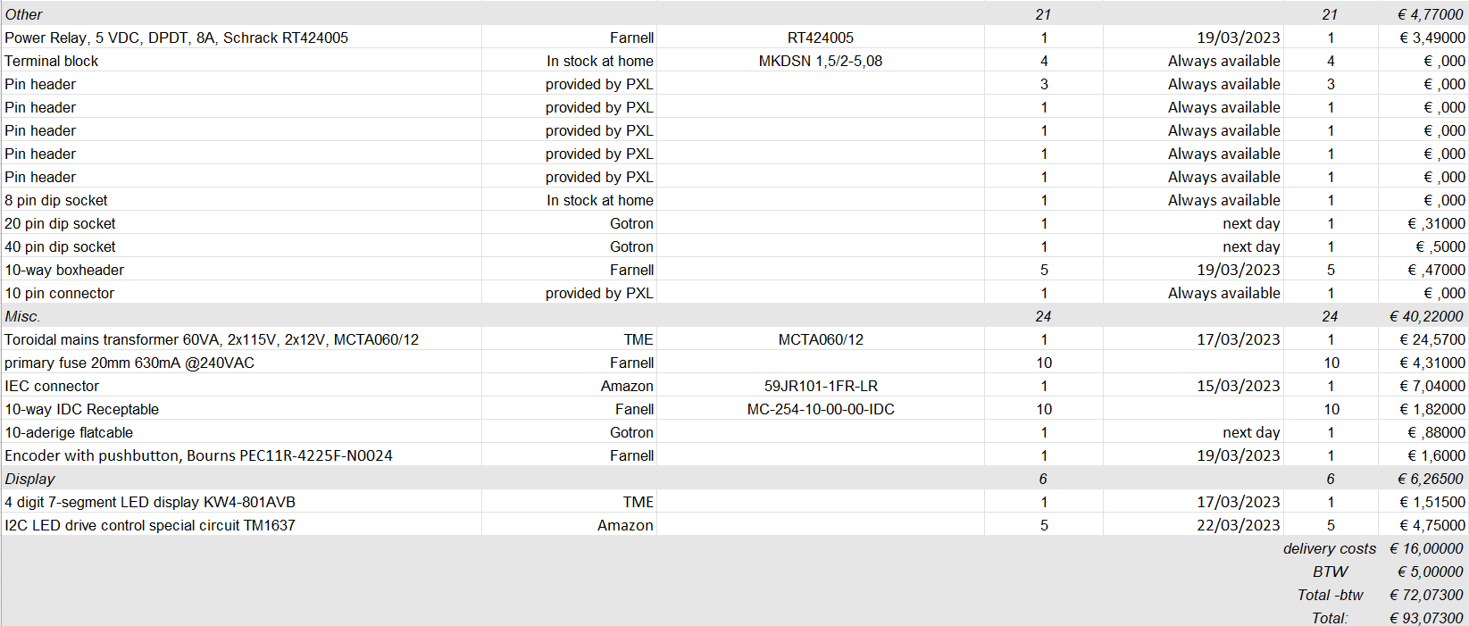€ 130 without sobering iron, because we have the inflation and taxes we need to pay.

Figure 1 Components

## Methods

### Route representation

Figure 2 presents a comprehensive overview of the project. The project entails software selection, ordering components, and conducting a footprint search. To meet the short deadline, it is crucial to have a solid plan in place.

Figure 2 Route representation

# Results

## Functionality Electrical schematic’s

### Power source

For supplying this soldering station, one toroidal transformer with 60VA and an output voltage of 2 x 12V was used. The secondary windings are connected to connector K1 and K2. Those windings will supply the circuit with each 12V. The two bridge rectifiers (B1 and B2), are connected with capacitors C1 and C4 and will deliver the rest of the PCB with a stable 5V. Also a Zener diode D2 is placed for high voltage protection.

Figure 3 Schematic power source

### Pulse width modulation

The pulse width modulation circuit is important by placing the IC2. This integrated circuit will reinforce the current voltage and the connection for the temperature sensor. This data would be send to the microprocessor. Be sure while testing this circuit, the IC2 is powered with +5V and ground. Also the two capacitors are placed as close as possible to the IC2 to reduce the noise in the circuit.

Figure 4 Schematic_Design_Pulse_width_modulation

### Microprocessor

Upon analyzing the schematic below, it is evident that all the components are interconnected at the microprocessor. The K12 connector serves the purpose of connecting the display board to the microprocessor board, utilising a flat cable. This provides the flexibility to place the display unit in a location of the user's preference. For this project, many of the pins are unconnected because those features does not require our specifications.

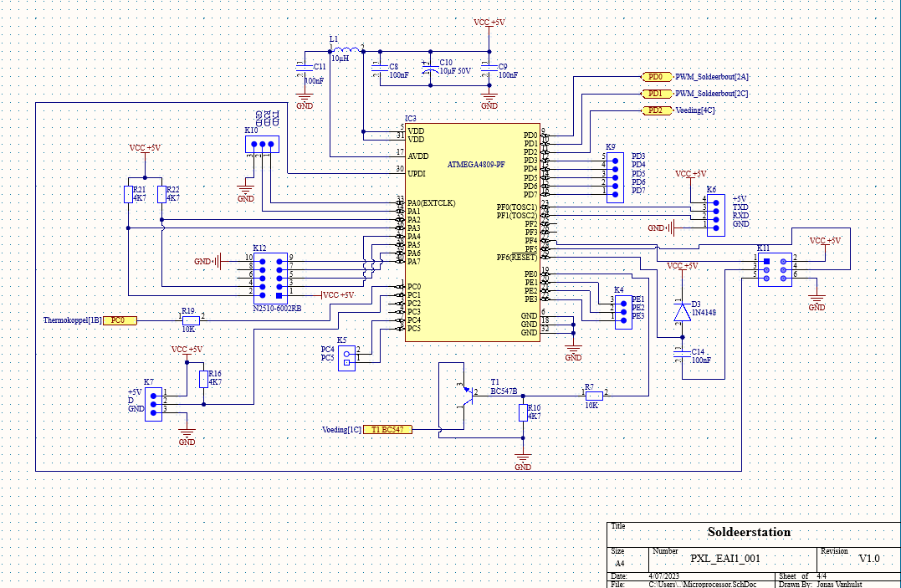

Figure 5 Schematic Design Microprocessor

### Display

In figure 6, the rotary encoder with a button is connected to the TM1637 led driver. This is the main driver that is popular to control the used 7-segment display. Connector K1 is the female connector of K12 which is placed to communicate to the microprocessor.

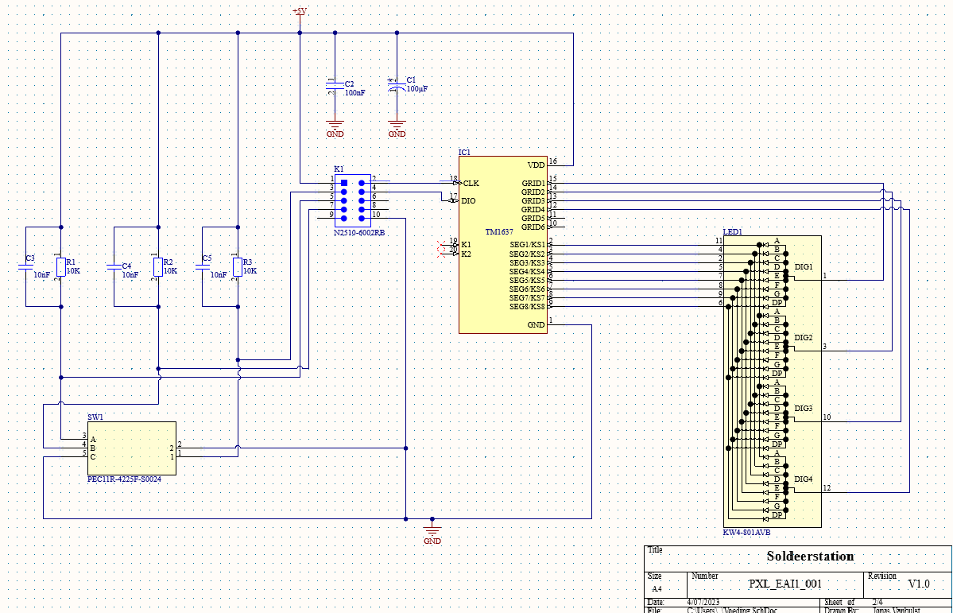

Figure 6 Schematic_Design_Display

### Thermocouple

Figure 7 visuals, the transistors that are placed as an open switch. The common mode choke ‘L2’ suppresses RF interference on the soldering iron cable. This is also called as the electromagnetic interference. If this component isn’t placed in this schematic, the risk of unwanted voltage current will have some consequences. By placing the mosfet, be sure that the gate is connected to the resistor and the source to the VIN for receiving the 5V.

Figure 7 Schematic_Design_Thermocouple

## PCB Design

### Display

By designing the Display PCB, the segment display is placed on the bottom layer. This has been done for a clean look on the PCB, this is done to put the display in front of the PCB and the components on the back. On figure 8, the rotary encoder (SW1) has a footprint of a pinheader. This will give you more freedom to place the encoder on a personal spot.

Figure 8 PCB_Design_Display

### Processor

By designing this PCB, it was very important to set capacitor ‘C2’ and ‘C3’ as close as possible to the ‘IC2 Opamp’. This function will be used to reduce the noise on the signal. By designing and measuring the components in real life, the footprint for ‘B1 & B2’ are not the right ones, to fix this problem the correct footprint where requested by ‘Ultra Librarian’. It would take a few days to receive the custom-made footprint. By further designing this PCB, the Lector told me to set the components as close as possible, so you will have a smaller PCB and this will reduce the prices.

Figure 9 PCB_Design_Processor

### 3D view

Figure 10 3D_Design_Display

Figure 11 3D_Design_Processor

## Case Design

### Case

For the case design the idea was to make a replica of the fames Wall-E. After designing the case, it was time to pre-build all the parts in fusion as an assembly. By using this feature the assembly won’t fail. After this last check the case is ready to print with the 3D-printer, the complete assembly could start! Thanks to printables (a free 3D source community) for the Wall-E design, here the eyes and wheels are downloaded to safe some time.

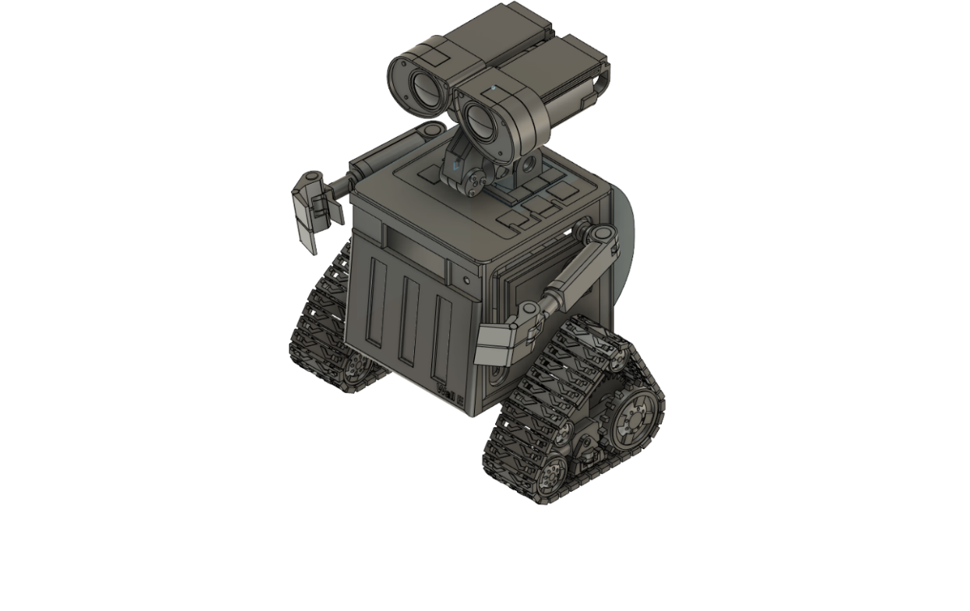

Figure 12 Case_Design

# Discussion

## Debugging and fixing

### Processor print

At the beginning the processor print was tested. Using a changeable AC transformer, the voltage could slowly rise. Starting with slowly rise the supply, the 12V on the input was reached by an input of 230V. Secondly it was time to test the processor, before this could happen the processes was removed to measure the 5V as output of the bridge rectifier. This was a great success, so the microprocessor could be placed. After the processor, the opamp was tested if the 5V was placed over pin 8, but here was the first issue. The problem was that the trace from a VIN (5v) was forgotten to place. So this problem was easy to solve by placing a wire from the microprocessor to the opamp ( pin 8 ). After solving this program the processor pint was completely solved and ready to test the display.

### Display print

Firstly the connection to the processor needs to be placed for receiving 5V from the processor. After successfully measuring the 5V over the TM1637 IC we could start powering the microprocessor. While powering the whole microprocessor the display was going into boot modus what is completely successful. After this successful test the program could be started. The settings of the soldering iron were installed on C3 and the temperature of the soldering iron was raising, but not enough. At the last lesson we found the problem using the oscilloscope. The biggest problem was not the circuit but the simple opamp, after taking the opamp from Patrick Hilven, the temperature started rising with an offset of 20°C. In my case the offset was 65°c, the board is actually completely working but for the optimal result, a new opamp needs to be purchased.  
  
By limiting time, the opamp could be purchased. Also the plan was to wait for purchasing a soldering iron until the PCB completely works. In my case it was time to place the order but the delivery time was just too late to use this at the presentation.

### Case design

Finally the last checks are with the case. Of course while designing this difficult case it couldn’t be perfect from the first time. In general the main problems were the holes to mount the plates to each other and the mount for the toroidal transformer was a little bit too small. For this problem a Dremel was used to make some extra space for the transformer. Thanks to the opportunity of printing at home, some spare parts were printed in case it would failed the first time by assembling. Lastly the problem using support for printing my plates the result wasn’t that beautiful by the raw lines that rested, so the idea was to use a sanding machine. By using this nice and helpful tool, the result was awesome. After this the whole case was painted again so it will be awesome an shiny. The last part that was printed were the wheels and the eyes. Thanks to the online design those were supplied with a DC-motor so the chose to add a circuit to send the signal to the motor was available, but to add this in the project the deadline was just to early. The main goal was to add two lamps into the eyes of Wall-E , so if you were soldering in the evening , the lights could switched on and you have a nice view on your soldering PCB.

## Reflection

During the project, I had the opportunity to utilize various new high-end tools. It was a great experience to enhance my skills in PCB design and assembling.  
  
While designing, I encountered some challenges, such as locating the right footprints and symbols. Once I mastered this aspect, progressing further became much easier. Thanks to my previous education in ‘Electromechanics’ , I quickly adapted using Altium Designer. I also had extensive experience in 3D modeling from years of experience with Fusion and Inventor, as well as utilising 3D printers. I enjoyed it so much that I even purchased my own Prusa printer.  
  
For the enclosure, I took great pride in replicating the body of the fames Wall-E. However, due to time limits, I had to utilize pre-existing designs for the eyes and wheels from freely available resources. Given more time, I would have preferred to design them myself.  
  
Of course, I am happy that everything functions as intended, and I can look forward to use my homemade soldering iron during the upcoming vacation.

# Reference list

[1] “Het zelfbouw-soldeerstation voor Weller RT-soldeerbouten”

[Available]: [elector Magazine.](https://www.elektormagazine.nl/magazine/elektor-177/59601)